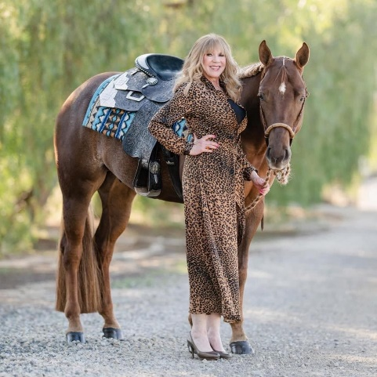

Meredith Landy

Meredith began showing in APHA at age 11 (1971) and has shown paint horses off and on throughout her life. As a youth, she became actively involved in the newly-formed AjPHA. From 1976 - 1977, she served as AjPHA Treasurer and in 1977, she was elected as AjPHA president.

Meredith has shown many APHA horses to world and reserve world championships in a wide variety of events, including western pleasure, hunter under saddle, pleasure driving, western riding and trail. She has been on the masters top 20 multiple years and has won several honor roll championships.

Since 2017, Meredith also has been a breeder of paint horses. She founded French Valley Farms and has been working with a small group of mares to produce APHA all around horses. Her stock is still young and unproven but French Valley Farms has been producing high quality horses that she hopes will enjoy great success in the show ring.

Meredith served as an APHA director or alternate representing California since 2019, serving on the Rules Advisory Committee for the last 3-1/2 years. She has also been on the board of the American Paint Horse Foundation since 2019. Meredith established a fund through APHF in honor of her niece, Suzanna Nelson. Meredith has been working to fund this scholarship, “Suzanna Smiles,” so it can award a perennial scholarship in the years to come.

