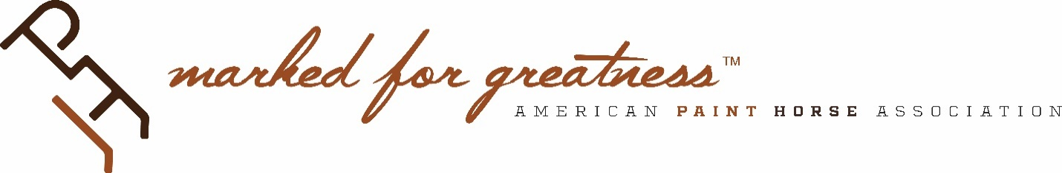

2020 Committee Priorities

Racing Advisory Committee

- Expand racing in Texas and the Northwest by adding one Paint incentive race in Montana and Texas to the 2 existing Paint incentive races: Harvest Cup Futurity and Rocky Mountain Futurity. (SP 1 – Customer Engagement)
- • Increase Racing Committee participation on fundraising events and cash flow to $15,000 for added paint racing opportunities. (SP 1 – Customer Engagement)

