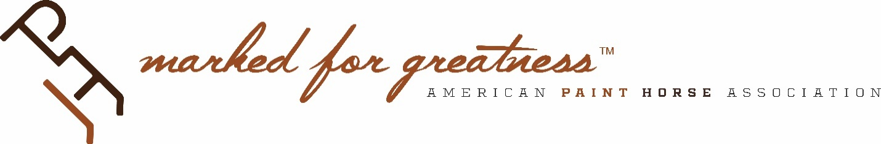
2020 Committee Priorities

International Advisory Committee

- Nurturing at least three initiatives in countries where international affiliates do not currently exist. (SP 2 – Educational Leadership)
- Hungary, July 24-26
- Croatia, TBD
- Slovenia, TBD
- Implementing at least three live international educational seminars that integrate educational/horsemanship clinics, print/digital information (translated when appropriate), and digital learning tools (APHA HorseIQ). (SP 2 – Educational Leadership)
- APHA HorseIQ: European Education Summit (Italy, Feb. 14-16)
- APHA HorseIQ: European Championship (Germany, Aug. 23-31)
- APHA HorseIQ: Oceania Education Summit (Australia, TBD)
- Expanding translation of APHA forms and distributing them widely at three major international events while providing on-site services in cooperation with that country’s international affiliate. (SP 1 – Customer Engagement)
- Spanish: translate DNA Hair Kit Request + Stallion Listing Form.
- Czech: translate Stallion Breeding Report + DNA Hair Kit Request.
- Croatian: translate Stallion Breeding Report + DNA Hair Kit Request.
- Slovakian: translate Registration Application + Stallion Breeding Report.
- Slovenian: translate Registration Application + Stallion Breeding Report.
- Russian: translate Transfer Report + Stallion Breeding Report.
- Foreign language forms widely distributed at European Championship (Germany, 08/20), Equita Lyon (France, 10/20), Fieracavalli (Italy, 11/20).
- Growing international registrations through partnerships with countries with established, independent studbooks. (SP 1 – Customer Engagement)
o Australia: research, develop proposal, pitch, and test run data processing (registrations,etc.) for PHAA as an alternative revenue stream.
- Brazil: research, develop proposal, pitch, and test run data processing (registrations, etc.) for ABCPaint as an alternative revenue stream.
- Costa Rica: maintain quarterly contact with ACRICAMDE to build a closer relationship and increase international registrations.
- New Zealand: maintain quarterly contact with Paint Horse Association of New Zealand, Inc. to build a closer relationship and increase international registrations.

