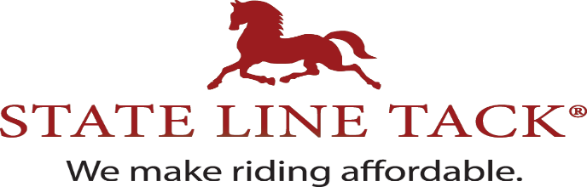

APHA Regional Club Show Sponsorship Program
State Line Tack loves supporting equine associations through corporate sponsorships. They also recognize Regional Clubs as the grass roots of the association and desires to provide local sponsorships to the APHA Regional Clubs in addition to their corporate sponsorship.

State Line Tack will provide the following:
Sponsorship Fee: Gift Certificates (# and amount will depend on size of event)
Postcards with discount offer
Vinyl 2’x4’ Banner
Goody Bag(s) - # of bags will depend on size of event
Ad/social image for your programs/Facebook/websites

Regional Clubs will do the following:
Distribute provided postcards to each exhibitor
Provide opportunities other spectators/equestrians to pick up postcards
Display banner in prominent spot (keep for any future events)
Announce sponsorship throughout show
State Line Tack ad in the show program (if you have one)
Promote using the social image/banner provided on website and/or Facebook
Provide images from the show with State Line Tack banner or an exhibitor with a goody bag for State Line Tack to use for promotions

Please contact Lisa.Borg@StateLineTack.com for additional information and to submit request for sponsorship.

