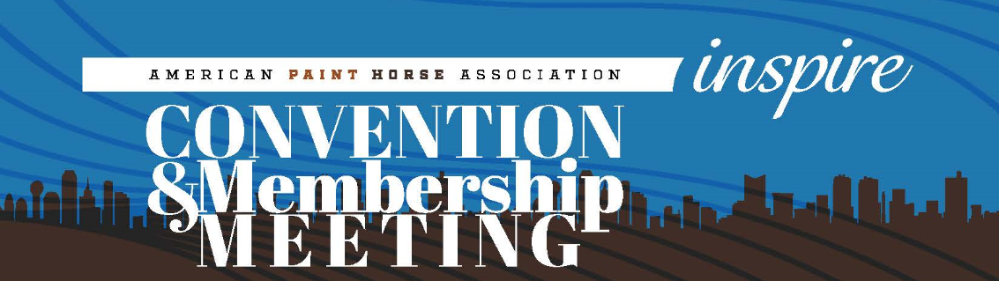

Where: Westin DFW Airport Hotel
4545 West John Carpenter Freeway
Irving, TX 75063

When: February 24-27, 2017
Go online to http://apha.com/events/convention/ for online hotel reservations or call 972-929-4500

Reservation deadline is February 6, 2017 for hotel and events.

Whether you’re an APHA member, national director, breeder, trainer, non-pro exhibitor or just a fan of Paint Horses, YOU’RE INVITED to attend the 2017 APHA Convention, February 24-27, 2017 in Irving, Texas. From educational seminars to fun parties to discussions about the association’s future, we’ve got something for everyone at our annual Convention.

The 2017 APHA Convention, seminars and parties are 100% FREE, but seating is limited, so please register below.

Enter the number of tickets you need in the field below.

________ Feb. 23 - Historic Fort Worth Stockyards & Dinner - $55

________ Feb. 24 - Welcome Reception - FREE

________ Feb. 25 - "Creating the Paint Horse Experience" - FREE

________ Feb 25 - The Game Plan Seminar - Lunch Included - $30

________ Feb. 25 - Planned Giving Seminar – FREE

________ Feb. 26 - Color Coat Genetics presented by Samantha Brooks – FREE

________ Feb. 28 - Hall of Fame Banquet & Dinner- $60

Total Due $______________

Please enclose your check or pay by credit card below:

Name: __________________________ Others attending: _________________________________________

Card #: ________________________________ Expiration Date: _______________ CVV: _____________

