NEW PROGRAM, NEW DISCOUNTS!
APHA and John Deere are excited to announce a new and enhanced partnership that will give APHA members special access to John Deere’s GreenFleet Loyalty Program. Along with the valuable equipment discounts members have already been privy to, members are now eligible for special parts savings, Home & Workshop Products discounts, and other members-only promotions.
“John Deere is committed to the success of customers whose work and pleasure is linked to the horse. Together with APHA, we are strengthening our equine and agricultural communities and building for the future,” said Auston Till, John Deere Manager of Equine Sales/Marketing. “The Equine Program for APHA members is John Deere’s way of rewarding and supporting the equine industry, the land, your success and passion for the horse.”
APHA members will automatically qualify by registering at JohnDeere.com/Equine. Members will have access to the following benefits:
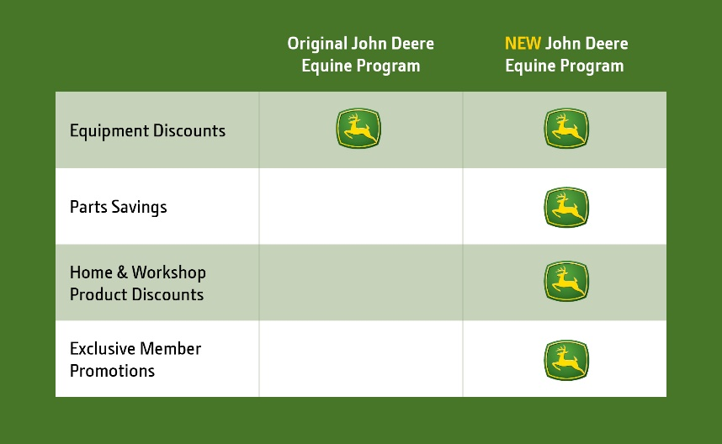

- Equipment Discounts – Special equine discounts on everything from mowers and tractors to Gator™ Utility Vehicles and hay equipment
- Parts Savings – Money-saving parts coupons and offers via email to help keep your equipment at its best
- Home & Workshop Product Discounts – A 10% discount off MSRP via email on eligible John Deere tools and workshop equipment such as: air compressors, generators and pressure washers
- Exclusive Member Promotions – New exclusive offers and promotions delivered to your inbox from GreenFleet Loyalty Rewards, along with insider tips for enhancing your equipment experience
To register, APHA members should visit JohnDeere.com/Equine, or call 877-462-2294. Once the registration is complete, members can receive their Equine Vouchers, and instantly access program benefits. Members can easily purchase online at JohnDeere.com/BuyOnline or by visiting a local John Deere dealer.

