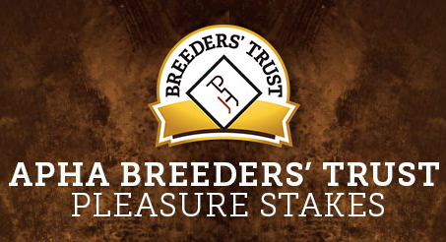

2018 APHA Breeders’ Trust 2-Year-Old Pleasure Stakes
HORSE NAME | OWNER | BREEDER | SIRE
ALLMYSNEAKERSAREFANCY | Sondra L. Hampton | Sondra L. Hampton | All Time Fancy
ALL ARTISTS INVITED | Mark D. Owen | Kristina Paradis | Invite The Artist
ALL BE HOT | Carlee Christian | Brad Perkins | All Time Fancy
ALLOCATED TIME | Cynthia Figueroa | Cynthia Figueroa | Allocate Your Assets
BEST IN BOOTS | Angela M. Finegan | Angela M. Finegan | RL Best of Sudden
BEYOND A COWBOY | MC' Dragon Ranch LLC | Marylyn Caliendo | The Original Cowboy
COWBOY IN ME | MC' Dragon Ranch LLC | Marylyn Caliendo | The Original Cowboy
GGR ON THE ROCKS | Chav3z Enterprises LLC | Angela or Susan Clark | The Rock
IRON KLAD INVESTMENT | Lisa M. Lavoie | Lisa M. Lavoie | HBF Iron Man
LAZY LOAFERS | Double C Acres | Tim & Cindy Snap | Lopin Lazy
MAKES ME SLEEPY | Tim & Cindy Snapp | Tim & Cindy Snap | Too Sleepy To Zip
MODEL OF SENSATION | Bonnie Habel | Roberta Tuso | I Only Date Models
ONE LAZY COWGIRL | Jackie L. Stevens | Patti & Anthony Cerio | Lopin Lazy
RISE ABOVE | Elizabeth R. Brewer | Elizabeth R. Brewer | All Time Fancy
SHEZA FLATLINER | Lisa K. Walter | Lisa K. Walter | VS Flatline
SLEEPING ON THE JOB | T. Blanchard or A. Chavez | Diane M. Gage | Too Sleepy To Zip
SST BILLY RAY | Steven & Susan Thompson | Steven & Susan Thompson | Nite Moves
SUCKER FOR A SUNDRESS | Liza Hassevoort | Williamson Paints & Quarter Horses | Never Compromise
THE CODE OF THE WEST | Dustin Stapleton | M. & D. Stapleton | VS Code Red
THE ULTIMATE CHROME | Susan Stocker | Cross Creek Farm | The Ultimate Fancy
UNDOUBTEDLY | Elizabeth R. Brewer | Elizabeth R. Brewer | No Doubt Im Lazy
WILLIWANNA KISS THIS | Cynthia Figueroa | Cynthia Figueroa | Winnies Willy
PENDING REGISTRATION | Anita Veldman | Anita Vedlman | Lazy Loper
PENDING REGISTRATION | Melinda R. Clark | Knapp Quarter Horses | How Bout This Cowboy
PENDING REGISTRATION | Angela M. Finegan | Angela M. Finegan | Hot Ones Only

