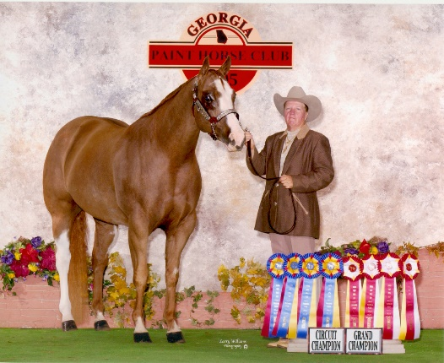 | Mary Ellen James
Address | 10505 60th St No  Pinellas Park, FL 33782
Education | Lakewood High School, St. Petersburg, Florida  St. Petersburg College  Business degree  Owner Anvil Acres Stables since 1972  Boarding 50 head of show and family horses  Formerly training and showing customer horses  Now enjoying being an Amateur and showing my own horses
Honors/Awards | APHA High Point Honor Roll Open Gelding  APHA High Point Honor Roll Amateur Gelding  Numerous Honor Roll and Zone Year end placings  Reserve World Champion 2 yr old mare  Numerous Superiors in Halter and Western Pleasure  Numerous Futurity wins in Halter
APHA/Paint Involvement | APHA National Director for the past 10 years  Member of the Professional Horseman Committee  Member of the Florida Paint Horse Club
Other Horse Involvement | I use my facility to host 4-H events and meetings  Seminars for Purina to educate local horse owners My trainers offers lessons and summer camp programs
Membership and Service | APHA National Director for the past 10 years  Professional Horseman Committee (since inception)  Florida Paint Horse Club member  AQHA member

